Online Shopping Cart Application

Business Scenario
A Super brand shop wants to sell variety of products to their customers, they want customers to buy products online and get those products within some business days, and they sell products like Laptops, Mobile, TV’s, Sports Items, Home Appliances, Footwear’s and many more.
As they want to track the customer details and the product they bought they need an application which can service their customers. They want the application to be accessed by their customers and buy the products online or on cash after they get the product.
Customer should be able to select multiple products; every product would have some items say for instance, if you consider Mobile as a product it could have items like Samsung, LG, HTC, Micro max and etc. in the same fashion other products must have some set of items, once the product is selected he could able to add to the cart, once he successfully added he should go for the payment.
The customer can also remove the selected items from the cart, but while adding and removing items to and from the cart assure that the exact items are added and removed, once the items are selected and the total amount to be paid for the items is displayed he/she goes for order option after ordering he should be able to enter his details and allow him to pay through net banking or debit card or credit card.
If the option like net banking is selected the customer should able to enter the customer id and password required for logging in to his/her account then he could able to pay the amount for the selected items only if the available balance is greater than the total price of the items, if not then a proper error message has to be displayed to the customer.
The customer can also pay the amount for the ordered items using his/her credit/debit card, when he selects the option for credit card he should able to enter his credit card number with the password, once he successfully pays the amount to the items, the amount he paid should be updated in his database meaning that the total amount he has spent from credit card.
When he uses the debit card he should able to provide his debit card number with password and go for payment if the sufficient balance is available if can successfully pay the amount for the ordered items then the same amount should be deducted from his account the same thing goes in net banking as well.
Students has to use databases for storing all the product and customer information’s whenever they operate on these information they have to use the technology like Java & Spring Boot/Microservices & for the UI you can use Angular/Rect.js/Vue.js. Students has to do client side validations for wrong inputs provided by the customer, say for instance if the user tries to add items without selecting the item then students need to display a message saying please select the item before adding, the same thing must be done for other scenario’s which are explained in the Activity section.
- Problem Statement
We assume that there are few tables already existing, so that Customer, Item, Product and Credit Card details should be stored manually with some amount of money in the Customer table, price of items in Product table, some list of items in Item table and Credit card information in Credit Card table. Firstly design a database table based on the following information’s. Create primary key, foreign key references and other constraints wherever necessary.

Customer
Contains details about the customer id, account number, customer name, password and debit card number

Credit Card
Contains details about the, credit card number customer id, password and amount

Address
Contains customers address details about address id, street name, state, city, pin and customer id.

Items
Contains details about items like item id, item name (store unique id for item id and item names like Laptop, Mobile, TV, Home Appliance, Footwear)

Product
Contains details about products like product id, product name, item id and price

Products Customers
Keeps track of customers purchasing the products like product id, customer id, debit card number, credit card number and price

Business process in the application and use cases

- After entering the URL the application should take the user to the home page which would have links of items like Mobiles, Laptops, TV’s, Sports and Footwear under these links list of products and their price should be displayed as a check box for e.g., Under Mobiles products like Samsung Rs.29000, iPhone Rs.60000, Lumia Rs.40000 etc, in the same way under Laptops list of laptops from different company and their price must be specified the same should be applied for TV’s, Sports and Footwear. Team can list at least 5 products for each Item. These should be buttons to add selected products, Remove All and Place order.

- The home page should also have a separate section for displaying images regarding some advertisements and offers which should be keep changing after some seconds.
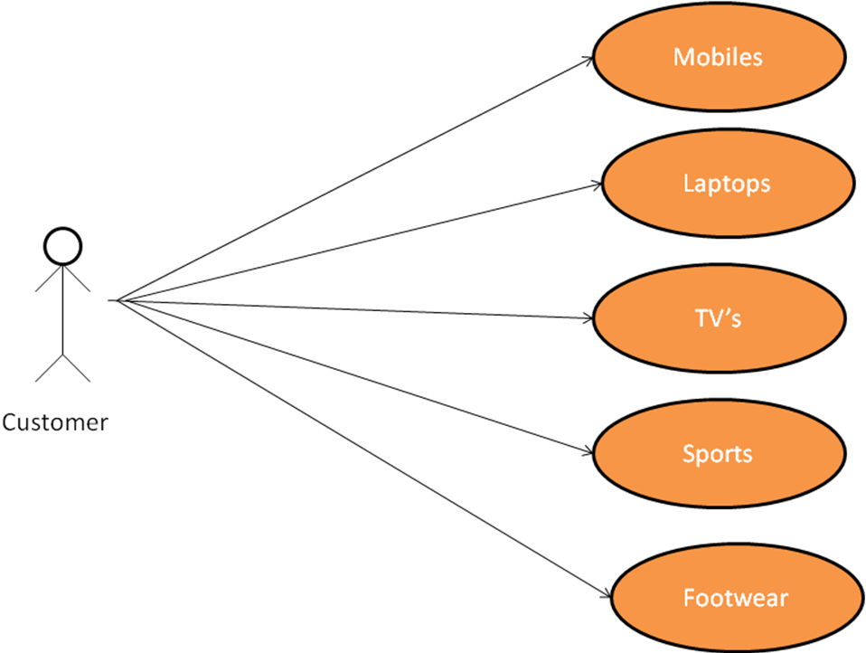

- Under Every Item list of products and their prices should be displayed

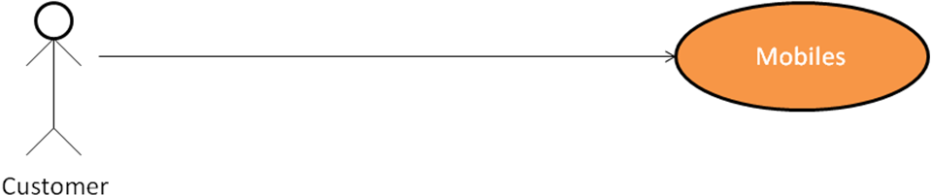
List of brands for Mobiles
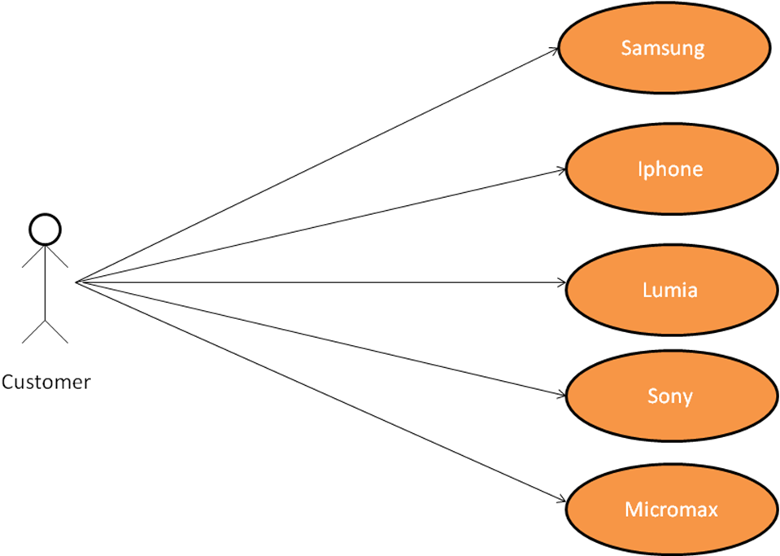

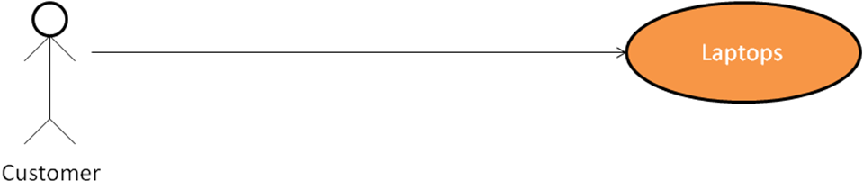
List of items for Laptops
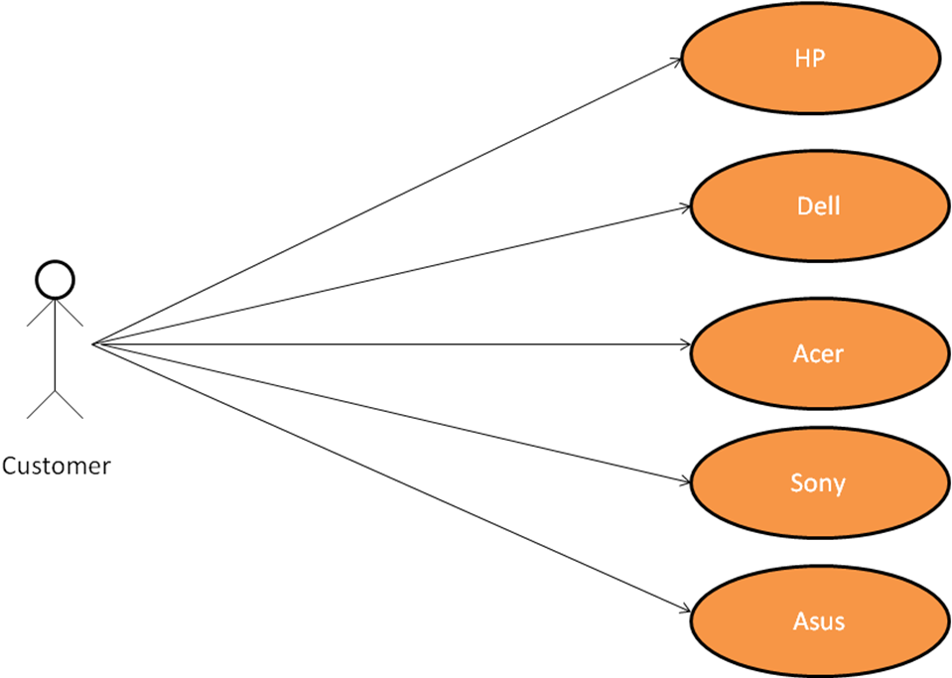

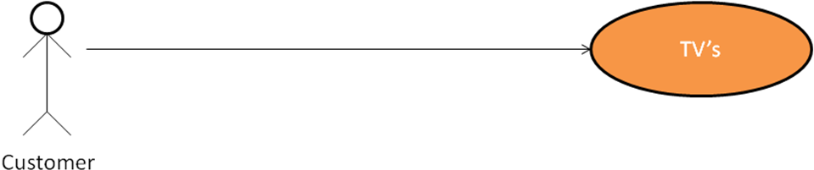
List of items for TVs
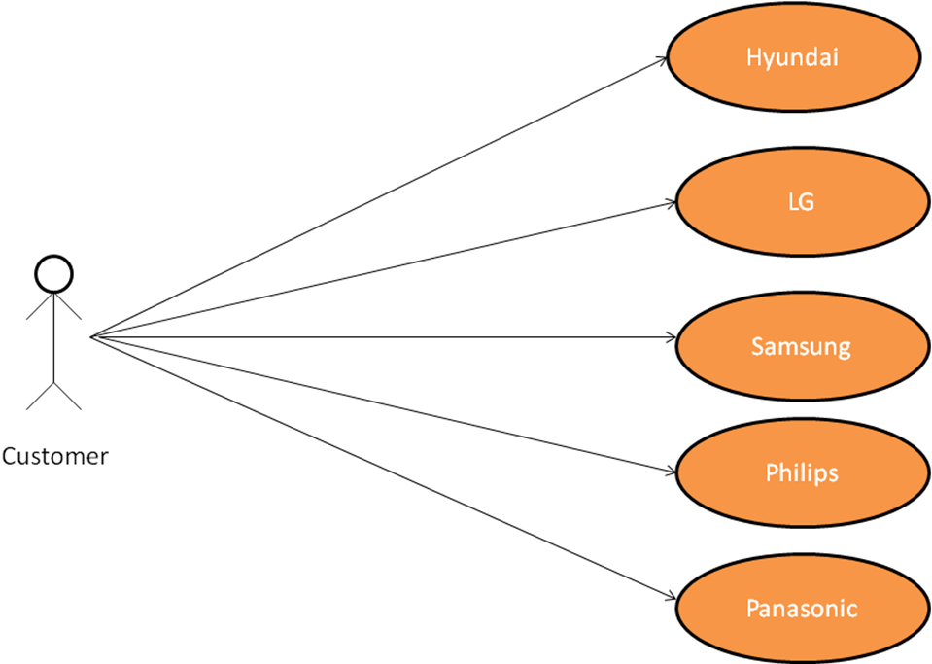

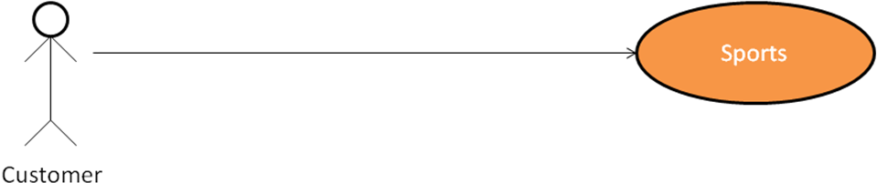
List of items for Sports
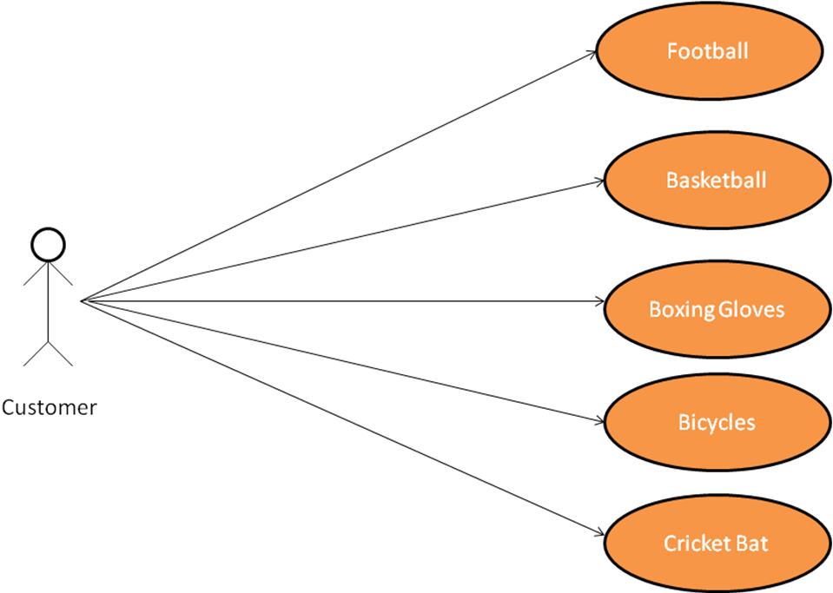

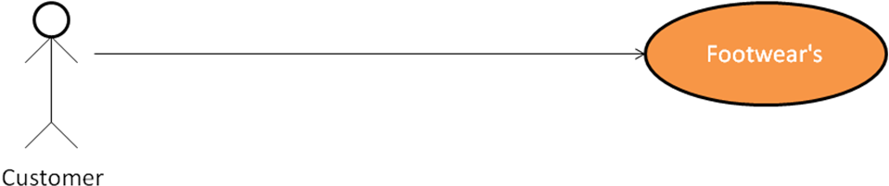
List of items for Footwears
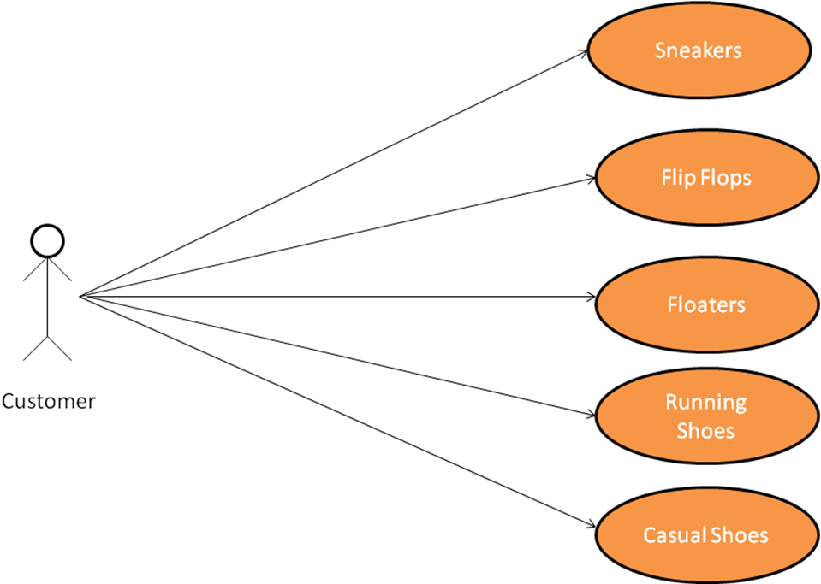
- Once items are selected your customer could able to add all the selected items to a cart when customer clicks on Add Selected, if the user clicks on remove all , the selected items must be cleared
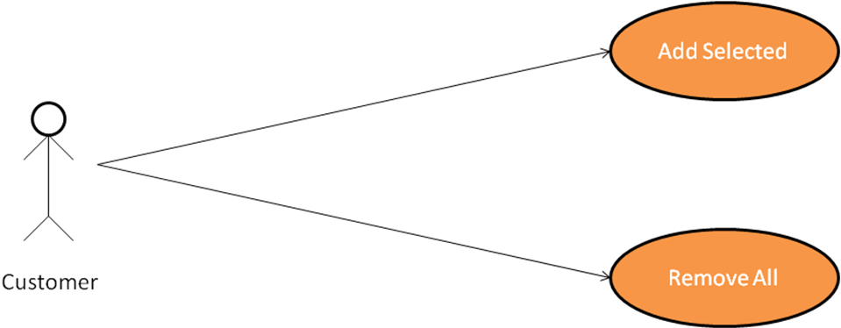
- If the user clicks on Add selected it should go to a new page displaying all the selected items and their price including the total price in a table with the following options, Add an item, Remove an item and Order, If user clicks on Add an Item the user should be again directed to the home page again having all the selected items checked in a checkbox, and should be able to select some more items if customer needs, If in case he wants to remove an Items the user should be again directed to the home page so that he can uncheck the items which were selected and again he should select Add Selected if he wants to proceed with the order, If in case customer wants to proceed with payment he should click on order, once customer clicks order he should be directed to the page with customer details where he can fill his details like name, address etc.
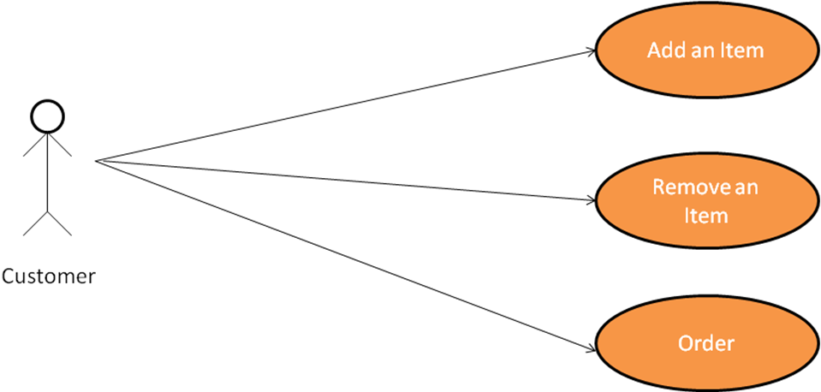
- After entering customer details he can proceed with payment options

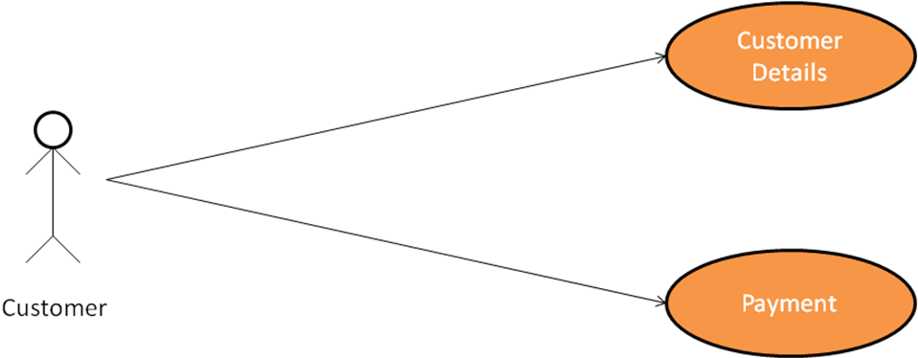
- Once he clicks on payment option he should be directed to a page where he can select the way he wants to pay for the items, either by credit card or debit card or net banking
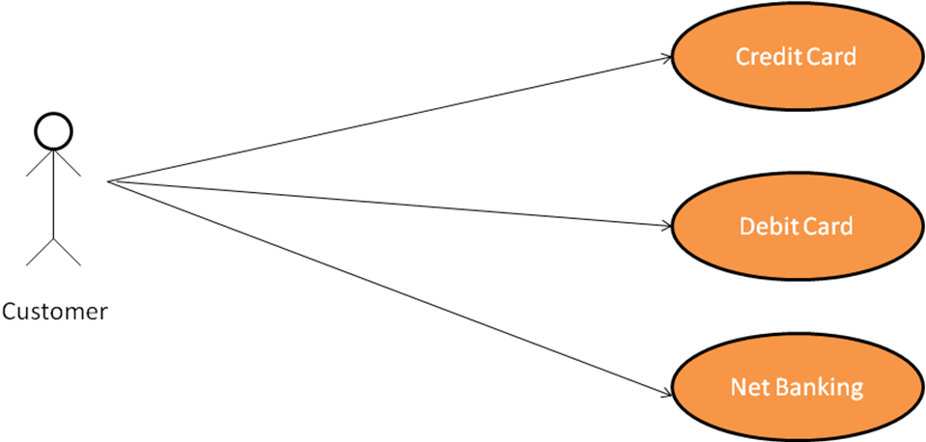
- On selecting one of the above options customer should be able to enter valid credentials and pay for the items
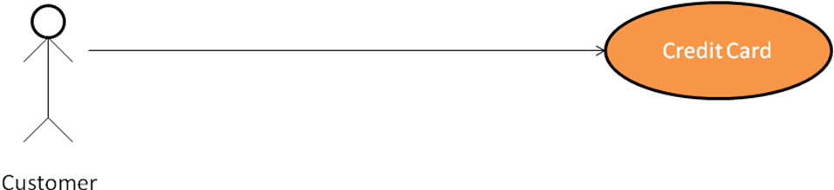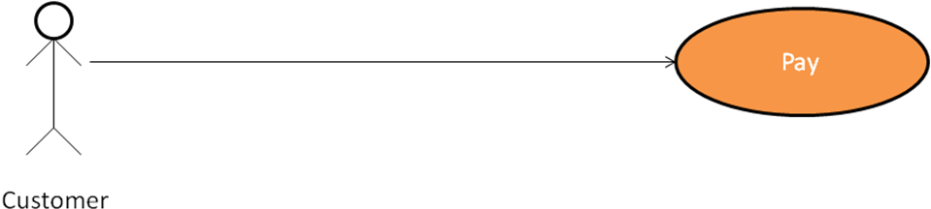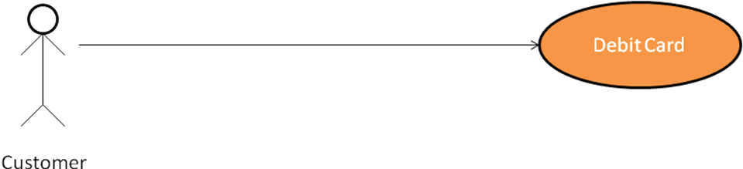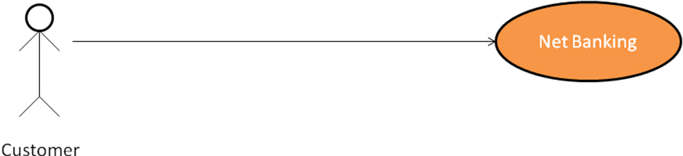

- Activities to be done by the students
Students should first create all the tables with the following columns and store some records inside them.
- Customer
  - customerId (primary key)
  - accountNumber
  - customerName
  - password
  - debitCardNumber
- CreditCard
  - creditCardNumber(primary key)
  - accountNumber
  - customerId (references Customer table)
  - password
  - amount
- Address
  - addressId (primary key)
  - streetName
  - city
  - state
  - pin
  - customerId (references Customer table)
- Item
  - itemId (primary key)
  - itemName
- Product
  - productId (primary key)
  - productName
  - itemId (references Item table)
  - price
- ProductsCustomers
  - productId
  - customerId
  - debitCardNumber
  - creditCardNumber
  - price
Once all the tables are created update ProductsCustomers with appropriate values when the payment is done, this is to keep track of customer and products
After all the database table design is over team must concentrate on development process, firstly create a home page which will have an heading welcome to online shopping please select the products below, the page should have a section with categories like Mobile, Laptops, TV’s, Sports and Footwear’s under these categories create checkboxes which is going to be the products the customer is going to select, ex: under Laptop have the following products with the prices beside the product like HP Rs. 34000, Dell Rs. 43000, Acer Rs. 28000, Sony Rs. 38000 and Asus Rs. 48000. Apply the same for all other Items, all these Items, Products and items should be displayed by them from the database, these information's are stored manually in a table but while displaying them team has to be fetching from the table since any changes made in the product would be automatically reflected if it isn’t hard coded.
Customer should be able to select multiple products; once he selects the products he should able to select two options,
- Add Selected
- Remove All
Upon clicking on Add Selected the selected items should be added in a Cart and the selected items, their price and total price in tabular format with other possible options(buttons) asking to Add an item, Remove an Item and Order, if user selects add an item option the page should be redirected to the home page again with all the selected items checked and allow customer to add some more items and select the Add Selected option, If user selects remove an item option the page should be again redirected to the home page with all the selected items checked and allow him to remove the items he wants to, later user should again select Add Selected which in turn brings him to the page where it displays the selected items, their price and total price in tabular format with the three buttons Add and Item, Remove an Item and Order. Whenever the customer does these operations team must take care adding and removing elements from the LinkedList.
Upon clicking on Remove All, the application should clear all the selected items
Once the items are selected and customer goes to Order option, the customer should be asked to enter his Name and Billing address in the form with the button Payment, After clicking on Payment option a page should be rendered to the user asking him to select the way of payment either through credit card or debit card or net banking based on the options he selects another page should be rendered asking the valid information’s.
    - If he selects the credit card then the page should ask his credit card number and password with the two buttons pay and reset, proper validations must be done for empty inputs, once the credentials are authentic the complete product and customer details should be maintained in a table productscustomers table, and the amount should be updated in the credit card table, if in case the credentials are invalid redirect him again to the same page saying invalid credentials so that he can once again enter the proper credentials
    - If he selects the debit card then the page should ask his debit card number and password with the two buttons pay and reset, proper validations must be done for empty inputs, once the credentials are authentic and the account has a sufficient balance then the amount should be deducted from his account and should display a message saying successfully ordered and also the productscustomers table should be updated with the proper details, if in case the amount is insufficient an error message should be displayed saying insufficient balance by redirecting to the home page, , if in case the credentials are invalid redirect him again to the same page saying invalid credentials so that he can once again enter the proper credentials.
    - If he selects the net banking then the page should ask his customer id and password with the two buttons pay and reset, proper validations must be done for empty inputs, once the credentials are authentic and the account has a sufficient balance then the amount should be deducted from his account and should display a message saying successfully ordered and also the productscustomers table should be updated with the proper details, if in case the amount is insufficient an error message should be displayed saying insufficient balance by redirecting to the home page, if in case the credentials are invalid redirect him again to the same page saying invalid credentials so that he can once again enter the proper credentials.

Payment: Once payment is done the amount can be debited from the customer account and show order placed, if in case balance is insufficient show the customer insufficient balance error and allow customer to edit his order to make payment or checkout without order

